Module 5
Assessment Questions:
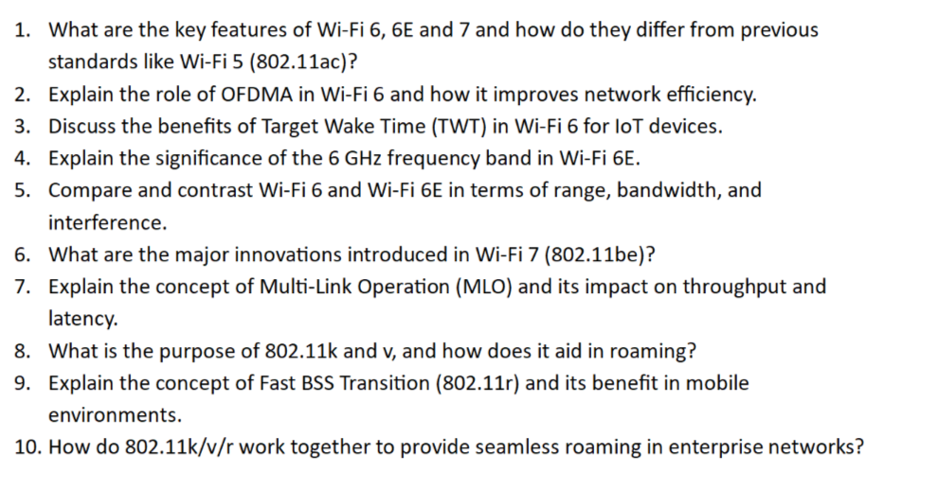
Answers :

1) What are the key features of Wi-Fi 6, 6E, and 7, and how do they differ from Wi-Fi 5 (802.11ac)?

Wi-Fi 5 (802.11ac)
Wi-Fi 5 mainly focused on increasing speed.

Key Features
- Operates only in the 5 GHz band
- Supports MU-MIMO (downlink only)
- Maximum channel width: 160 MHz
- Maximum modulation: 256-QAM
- Suitable for HD streaming and normal office usage

Limitations
- No support for 2.4 GHz
- Less efficient in crowded environments
- Higher latency when many devices connect simultaneously

Wi-Fi 6 (802.11ax)
Wi-Fi 6 is designed for efficiency, capacity, and performance.

Major Improvements
- Supports both 2.4 GHz and 5 GHz
- Introduces OFDMA
- Supports uplink and downlink MU-MIMO
- Uses 1024-QAM
- Includes Target Wake Time (TWT)
- Better battery life for connected devices
- Reduced latency

Benefits
- Handles crowded networks efficiently
- Ideal for homes, offices, stadiums, and airports

Wi-Fi 6E
Wi-Fi 6E is essentially Wi-Fi 6 extended into the 6 GHz band.

Additional Features
- Supports 2.4 GHz, 5 GHz, and 6 GHz
- Access to many new non-overlapping channels
- Extremely low interference
- Lower latency
- Better for AR, VR, and gaming

Wi-Fi 7 (802.11be)
Wi-Fi 7 is the next generation focused on ultra-high speed and ultra-low latency.

New Innovations
- Supports 320 MHz channels
- Uses 4096-QAM
- Introduces Multi-Link Operation (MLO)
- Multi-RU allocation
- Preamble puncturing
- Extremely low latency

Applications
- 8K streaming
- Cloud gaming
- AR/VR
- Industrial automation

Comparison Table
Feature | Wi-Fi 5 | Wi-Fi 6 | Wi-Fi 6E | Wi-Fi 7
Frequency Bands | 5 GHz | 2.4 & 5 GHz | 2.4, 5 & 6 GHz | 2.4, 5 & 6 GHz
Max QAM | 256 | 1024 | 1024 | 4096
Channel Width | 160 MHz | 160 MHz | 160 MHz | 320 MHz
OFDMA | No | Yes | Yes | Enhanced
MLO | No | No | No | Yes

2) Explain the role of OFDMA in Wi-Fi 6 and how it improves network efficiency.

What is OFDMA?
OFDMA stands for Orthogonal Frequency Division Multiple Access.
It divides a Wi-Fi channel into smaller sub-channels called Resource Units (RUs).

Traditional Wi-Fi
- One device transmits at a time.
- Other devices wait.

Wi-Fi 6 with OFDMA
- Multiple devices can transmit simultaneously.
- Each device gets its own RU.

Example
A 20 MHz channel can be divided among:
- Mobile phone
- Laptop
- Smart TV
- IoT sensor
All can communicate at once.

Advantages
- Lower latency
- Better spectrum utilization
- Improved efficiency
- Reduced waiting time
- Excellent performance in crowded networks

Real-World Scenario
In a classroom with 50 students, OFDMA allows many devices to send data simultaneously rather than one after another.

3) Discuss the benefits of Target Wake Time (TWT) in Wi-Fi 6 for IoT devices.

What is TWT?
TWT stands for Target Wake Time.
It allows an access point and client device to schedule exactly when communication will occur.

How It Works
- Device sleeps most of the time.
- Wakes up only at predetermined intervals.
- Exchanges data quickly.
- Returns to sleep.

Benefits for IoT Devices
- Significant battery savings
- Longer device lifetime
- Reduced channel congestion
- Better power management
- Improved network scalability

Example
A smart temperature sensor may wake every 10 minutes, send data, and sleep again.

Applications
- Smart locks
- Sensors
- Wearables
- Smart meters
- Home automation devices

4) Explain the significance of the 6 GHz frequency band in Wi-Fi 6E.

Why 6 GHz Matters
The 6 GHz band provides a completely new spectrum exclusively for modern Wi-Fi devices.

Key Advantages
- More available bandwidth
- More non-overlapping channels
- Less interference
- Lower latency
- No legacy device congestion

Technical Benefits
- Up to seven 160 MHz channels
- Excellent for high-bandwidth applications

Applications
- VR/AR
- 4K/8K streaming
- Cloud gaming
- Video conferencing

Important Note
Higher frequency means slightly shorter range compared to 5 GHz.

5) Compare Wi-Fi 6 and Wi-Fi 6E in terms of range, bandwidth, and interference.
Parameter | Wi-Fi 6 | Wi-Fi 6E
Range | Better | Slightly Lower
Bandwidth | High | Very High
Interference | Moderate | Very Low
Congestion | Possible | Minimal
Best Use | General Networking | Premium Applications

Detailed Explanation

Range
- Wi-Fi 6 on 2.4/5 GHz covers larger areas.
- Wi-Fi 6E on 6 GHz has shorter coverage.

Bandwidth
- Wi-Fi 6E offers much wider clean spectrum.

Interference
- Wi-Fi 6E experiences almost no interference due to the new band.

5) Compare Wi-Fi 6 and Wi-Fi 6E in terms of range, bandwidth, and interference.
Parameter | Wi-Fi 6 | Wi-Fi 6E
Range | Better | Slightly Lower
Bandwidth | High | Very High
Interference | Moderate | Very Low
Congestion | Possible | Minimal
Best Use | General Networking | Premium Applications

Detailed Explanation

Range
- Wi-Fi 6 on 2.4/5 GHz covers larger areas.
- Wi-Fi 6E on 6 GHz has shorter coverage.

Bandwidth
- Wi-Fi 6E offers much wider clean spectrum.

Interference
- Wi-Fi 6E experiences almost no interference due to the new band.

6) What are the major innovations introduced in Wi-Fi 7 (802.11be)?

Key Innovations

1. Multi-Link Operation (MLO)
Uses multiple bands simultaneously.

2. 320 MHz Channels
Doubles channel width.

3. 4096-QAM
Improves data density.

4. Multi-RU
Efficient resource allocation.

5. Preamble Puncturing
Uses partially blocked channels effectively.

Benefits
- Up to 46 Gbps theoretical speed
- Ultra-low latency
- Higher reliability
- Better performance in congested environments

7) Explain Multi-Link Operation (MLO) and its impact on throughput and latency.

What is MLO?
MLO allows a device to use multiple wireless links simultaneously.
For example:
- 5 GHz + 6 GHz together

How It Works
- Data packets are split across multiple bands.
- Traffic can dynamically switch between links.

Impact on Throughput
- Aggregate bandwidth increases significantly.
- Faster downloads and uploads.

Impact on Latency
- Packets take the fastest available path.
- Reduces delay and jitter.

Reliability
If one link degrades, traffic instantly shifts to another.

Example
Gaming laptop using both 5 GHz and 6 GHz simultaneously.

8) What is the purpose of 802.11k and 802.11v, and how does it aid roaming?

802.11k – Neighbor Reports
- AP provides a list of nearby access points.
- Client knows where to roam next.

802.11v – Network Assisted Roaming
- Network suggests the best AP.
- Helps clients make smarter roaming decisions.

Benefits
- Faster roaming
- Better signal quality
- Reduced scanning time
- Improved user experience

Example
While walking through an office, your phone receives guidance on the next AP.

9) Explain Fast BSS Transition (802.11r) and its benefit in mobile environments.

What is 802.11r?
802.11r enables fast roaming by reducing authentication time.

Traditional Roaming
- Full authentication occurs every time.
- Causes delay.

With 802.11r
- Security keys are pre-shared.
- Handoff occurs quickly.

Benefits
- Roaming delay reduced to less than 50 ms
- Seamless voice calls
- Smooth video streaming
- No packet loss

Applications
- VoIP
- Video conferencing
- Warehouse scanners
- Mobile healthcare devices

10) How do 802.11k/v/r work together to provide seamless roaming?

Combined Operation

Step 1: 802.11k
Provides neighboring AP information.

Step 2: 802.11v
Suggests the optimal AP.

Step 3: 802.11r
Performs rapid secure handoff.

Roaming Process
- Device signal weakens.
- 802.11k identifies nearby APs.
- 802.11v recommends best AP.
- 802.11r completes fast authentication.
- Connection continues uninterrupted.

Benefits
- Near-zero roaming delay
- Better voice quality
- Uninterrupted video calls
- Improved mobility
- Enterprise-grade wireless experience

Real-World Example
A doctor moving across a hospital while on a VoWiFi call experiences no call drop.

